VERY IMPORTANT- PLEASE NOTE

CHANGE OF DATE

FOR THE

AWHA MARE AND FOAL GALA SHOW

TO

SATURDAY APRIL 4TH 2009
AT

WERRIBEE PARK EQUESTRIAN CENTRE

K ROAD

WERRIBEE VICTORIA.

Close of entries extended to March 18th 2009

THE AWHA EFA DRESSAGE IS UNAFFECTED
AND WILL RUN ON MARCH THE 14TH AS SCHEDULED.

AFTER LONG DISCUSSIONS WITH WERRIBEE PARK, THE AWHA COMMITTEE FEEL THAT THE VERY LARGE ARABIAN SHOWS SCHEDULED TO RUN FROM THE 12-22ND OF MARCH WOULD HAVE A DETRIMENTAL IMPACT ON THE RELAXED AND INVITING ATMOSPHERE WE STRIVE FOR TO MAKE THE FIRST OUTINGS FOR MANY FOALS, YOUNGSTERS AND OWNERS A PLEASANT AND NON-THREATENING EXPERIENCE.

STABLING WOULD ALSO HAVE BEEN EXCEEDINGLY DIFFICULT TO OBTAIN OWING TO THE LARGE NUMBER OF HORSES IN ATTENDANCE FOR THE ARABIAN SHOWS.

We apologise to the EFA dressage competitors who normally enter our ridden classes.
The decision has not been an easy nor a convenient one.

If you don’t have a horse to bring, you might like to bring yourselves and either help on the day or just be there for a great event. We hope to have a number of stallion services available for tender.
If you can help out please contact Julie on Ph 5781 1977 or email jsmout@darebin.vic.gov.au
2009 AWHA Gala Mare and Foal Show Class listing

Saturday April 4th 2009. WPNEC
Age based on August 1st.
1F | Yearlings Female
  1M | Yearlings Male
2F | 2 year olds Female
2M | 2 year olds Male
 | AWHA Champion and Reserve Champion Junior Horse (Classes 1F-2M)
3F | Females born 1/8/08 to 1/12/08
3M | Males born 1/8/08 to 1/12/08
4F | Females born on or after 1/12/08
4M | Males born on or after 1/12/08
 | AWHA Champion and Reserve Champion Foal (Classes 3F-4M)
5W | Warmblood broodmare in foal/with foal at foot
5TA | Thoroughbred/Anglo broodmare in foal/with foal at foot
6W | Warmblood broodmare dry (must provide proof of previous foal/service)
6TA | TB/Anglo broodmare dry (must provide proof of previous foal/service)
 | AWHA Champion & Reserve Broodmare (classes 5W-6TA)
7F | 3 yo Female
7M | 3 yo Male
8F | 4 yo Female
8M | 4 yo Male
9F | 5 yo and over Female
9M | 5 yo and over Male
 | AWHA Champion and Reserve Champion Senior Horse (Classes 7F-9M)
10P | Progeny Class- 3 offspring of same Sire or Dam (enter on day)
11R | Ridden class- 3 & 4 year olds
12R | Ridden class- 5 year olds
13R | Ridden class- 6 year old and over
AWHA Champion and Reserve Champion Ridden Horse
(Classes 11R, 12R, 13R)
All horses entered in the Led Classes must be registered with an approved Warmblood breed society. Dry Broodmares must provide proof of previous foal or stallion service with entry
All horses entered in Material Classes must be registered with an approved Warmblood breed society or the EFA.
*** A copy of registration papers MUST BE INCLUDED with your entry ***
NB- AWHA registrations pending i.e. submitted and paid for will be accepted (with copy of application).
The organisers reserve the right to cancel, divide or combine any class, alter the advertised times or refuse any entry.
You may have an assistant for the led classes; however they must also sign the appropriate waiver for EFA/AWHA members, or pay the $20 levy and sign the form for AON insurance for non-members

Show Secretary- Mary McBurnie PO Box 14, Pheasant Creek. 3757 ph 5786 1584
Entry Fees- led classes $22, ridden classes $27.50, WPNEC facility fee per horse $11
Entries close 18th March 2009.No Late Entries

AWHA Dressage –official 1.2, 1.4, 2.2, 2.4, 3.2, 3.4, 4.2, 4.4
SATURDAY MARCH 14TH 2009 (DATE UNCHANGED)
Event Secretary-Dr Barbara Burrows 11 Harcourt St, Hawthorn 3132 Ph 9882 5280
Entries close 20th February 2009
Entry Fees: AWHA Members- $23 Non- AWHA Members- $28.50. (includes DV Levy) WPNEC Facility Fee $11 per horse. SSAE (A4) for return of draws or supply e-mail address
How to enter correctly. PLEASE READ
- Fill in Entry form (if the owner is not showing/riding the horse, please include the presenter’s/rider’s name)
- Include info sheet concerning your horse tracing details and description are compulsory other information is not (but would be nice)
- Sex of horse: E=entire- colt or stallion, F= female- mare or filly, G = gelding
- Include copy of your horse’s papers
- Include signed disclaimer- AWHA/EFA disclaimers for AWHA/EFA members only
or AON insurance disclaimer for non-AWHA/EFA ($20 fee) members.
DO NOT FILL OUT BOTH FORMS- only one per person. No form- no participation
- Remember- any handlers entering the arena must also sign the appropriate disclaimer form
- Payments
- For each class entered
- Facility fee for each horse entered (if horse is competing in another discipline at the same event only one facility fee is required)
- Insurance levy OF $20 if not AWHA or EFA member
  - Cheques made payable to AWHA F class
Post prior to the 18th of March!!!!!!!! Entries postmarked by this date will be accepted. Anything postmarked after this date may be accepted at the discretion of the committee, but this is not guaranteed.
Entries without all required paperwork will not be entered until all requirements are met!
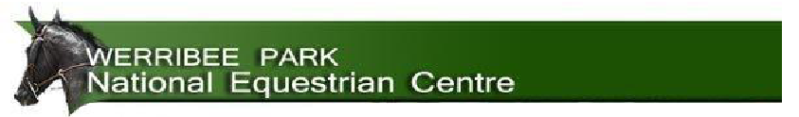
Risk Management Conditions
The information set out within this document must be included in the Prize Schedule, Competitor Information and/or
Official Program for your event/s.
1. Werribee Park National Equestrian Centre Committee of Management consider it a privilege that you are
allowed to bring your dog to this venue. We insist you keep your dog under effective control at all times.
2. Approved Safety Helmets must be worn at all times when riding
3. Cross Country obstacles must not be jumped/used unless a non riding adult aged eighteen years and over is present.
4. Riding of horses bareback is prohibited
5. Riding of rugged and/or unbridled horses is prohibited
6. Any person may lead a maximum of two horses while mounted
7. Stallions must at all times be in the control of a person aged seventeen years or more, when led or ridden
8. Horses are not permitted within/upon the quadrangle (between the barn & Indoor 1)
9. Horses are not permitted near pedestrian door ways
10. Bicycles are not permitted in the Indoor Arenas
11. Bicycles are not permitted near doors designated as public entrances or exits
12. Motor Cyclist riders must wear approved safety helmets and hold the appropriate licence
13. Speed limits must be adhered to at all times
14. Power leads must not be on the ground
15. Construction of portable/tape yards is prohibited
16. Alcohol must not be consumed in the Indoor Arenas, unless purchased from the licensed bar located in Indoor Arena No 1
17. Please observe all signs at the venue
The protocol for the Show is as follows:
Age based on 1st August
The protocol for In Hand Classes is as follows:
1. All exhibits are to enter ring together led in at walk and presented to the judges, near side facing, in the designated area to be scored for type and conformation.
2. Upon completion of the type and conformation assessment, all exhibits are to return to the collecting area.
3. At the judge’s indication, each exhibit will individually re-present to the judges and when asked to move off, commence one circuit of the exhibition triangle (see diagram below) in walk, followed by a second circuit in trot.
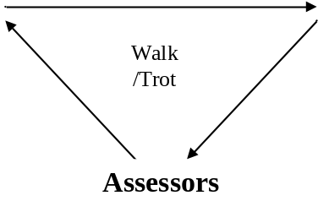
Please note- the triangle is used to demonstrate your horse’s ability to track straight. It is to your advantage to follow these directions to show your horse to its best advantage.
4. At completion the exhibit is to re-present to the judges while scores are compiled and announced
5. After presentation all exhibits are to remain in close proximity to the judging area.
6. At the completion of the last exhibit, all competitors are to return to the arena for announcement of placegetters.
Winners of classes 1F-2M must be presented for the judging of the Champion Junior Horse and Reserve Champion
Winners of classes 3F-4M must be presented for the judging of the Champion Foal and Reserve Champion.
Winners of classes 5W, 5TA, 6W, 6TA must be presented for the judging of the Champion Broodmare and Reserve Champion
Winners of classes 7F-9M must be presented for the judging of the Champion Senior Horse and Reserve Champion

The protocol for Material Classes is as follows:
1.Horses to enter the ring, in groups of 3 (or as otherwise indicated), at a walk in a clockwise direction at the discretion of the ring steward /judge and may be asked to trot and canter as a group.
2. All competitors will leave the arena and return individually when called. Changes of gait and direction will be indicated by the ring steward/judge.
3. At the completion of the last exhibit, all competitors are to return to the arena for announcement of placegetters
4. Judging: 25% general impression; 75% gaits; to be judged on quality, substance, soundness, rideability and suitability to Olympic and related equestrian sports (based on walk, trot, canter, general impression as a performance horse and conformation. Each criterion will be marked out of 10 possible total 40)

Assessors
Winners of classes 11R-13R must be presented for the judging of the Champion Ridden Horse and Reserve Champion

Progeny Classes
3 offspring by same stallion or from the same mare.
Enter the arena as group and present to the judges as per led classes in their group of 3

This form is for AWHA or EFA members only…

DISCLAIMER STATEMENT
Australian Warmblood Horse Association Limited, Vic Branch
ACN 063 906 150 ABN 560 639 061 50

Event: 2009 Gala Mare and Foal Show (hereafter referred to as the “EVENT”)

I acknowledge and agree as a condition of participating that neither the AWHA and its state bodies or any subdivision thereof, participants, officials, volunteers, medical personnel, any persons, promoters, sponsors, advertisers, owners and lessees of premises used to conduct the EVENT, shall be under any liability for my death or any bodily injury, loss or damage which may be sustained or incurred by me, as a result of participation in or being present at the EVENT, except in regard to any rights I may have arising under the Trade Practices Act 1974.

I acknowledge that equestrian activities are dangerous and that accidents causing death, bodily injury, disability and property damage, can, and do happen.

BY SIGNING HEREUNDER I CONFIRM HAVING READ AND UNDERSTOOD THE CONTENTS OF THIS DICLAIMER.

Print Name Here Sign Here Date

………………………………………………………………………………………………………………………..

PARENT/GUARDIAN CONSENT FOR UNDER 18 YEAR OLD PARTICIPANTS

I………………………………………….being the parent/guardian of …………………………………………………… confirm that I have read the whole of this document and have taken all necessary actions to ensure that I am aware of the activity which the above named will be asked to participate in and consent to him/her participating. In doing so, I acknowledge that equestrian activities are dangerous and that accidents causing death, bodily injury, disability and property damage, can, and do happen. I agree that neither the AWHA and its state bodies or any subdivision thereof, participants, officials, volunteers, medical personnel, any persons, promoters, sponsors, advertisers, owners and lessees of premises used to conduct the EVENT, shall be under any liability for my death or any bodily injury, loss or damage which may be suffered or incurred by the above named or by me, as a result of participation in or being present at the EVENT, except for any rights the above named or I may have arising under the Trade Practices Act 1974 (Cth) (or similar State Legislation).

By signing hereunder I confirm having read and understood the contents of this disclaimer

…………………………………………………….. …………………………………………………….
Name (block letters) Signed

Dated this……………………….Day of………………………..2009

PLEASE RETURN THE SIGNED FORMS WITH YOUR ENTRIES. NO FORM, NO PARTICIPATION.

IF YOU ARE HAVING AN ASSISTANT IN THE ARENA WITH YOU, THEY MUST ALSO COMPLETE A DISCLAIMER FORM (AWHA/EFA MEMBERS) OR PAY THE $20 INSURANCE LEVY AND COMPLETE THE AON WAIVER FORM

This form is for persons who are not members of the AWHA or EFA…
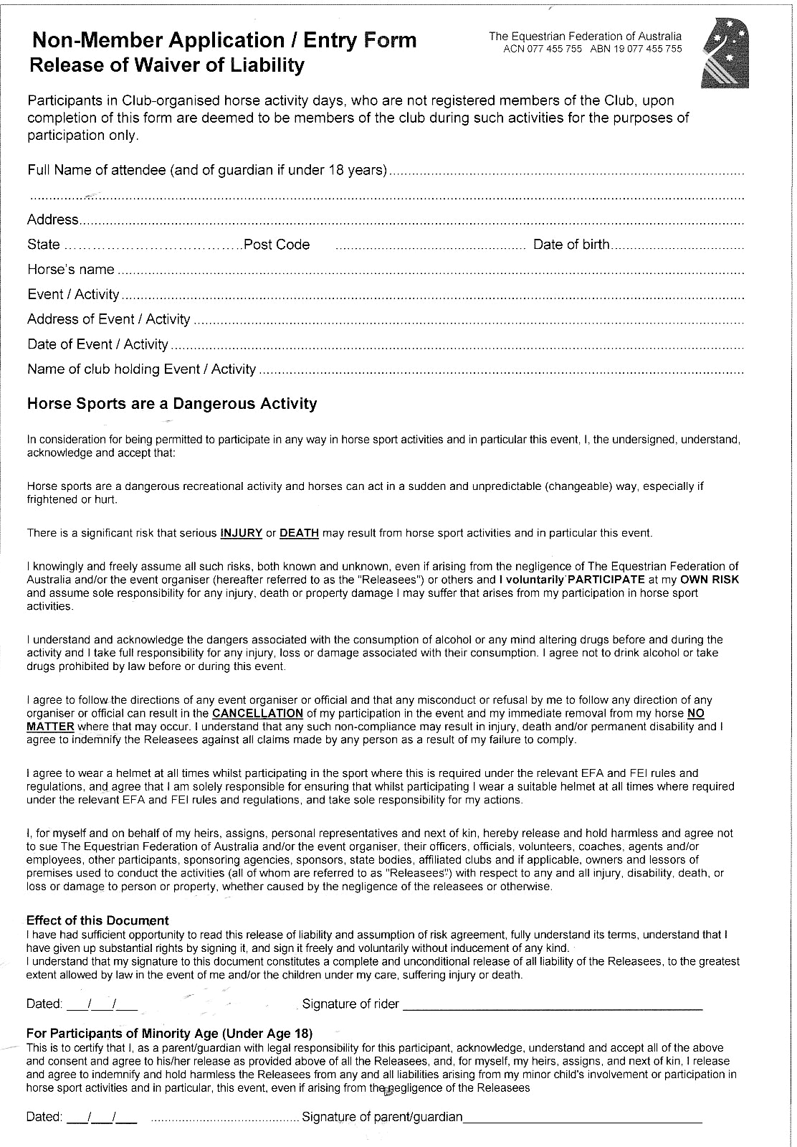
Please complete only one form per person
Information Sheet
Compulsory Section
Horse’s Name:…………………………………………………………………………………

Owner’s Name:………………………………………………………………………………...

Description | Height | Colour | Brands | Sex
Description |  |  |  | E F G (please circle)
Address of property horse will originate from
Address of property horse will return to

Sire::……………………..

Dam:……………………..

Dam’s Sire:………………………….

Registered With (associations)……………………………………………………….

Performance/Show results………………………………………………………………..…….

………………………………………………………………………………………..………………

………………………………………………………………………………………………….……

……………………………………………………………………………………………………….

……………………………………………………………………………………………………….
Additional information:

………………………………………………………………………………………………….……

……….………………………………………………………………………………………………

……………….………………………………………………………………………………………

………………………..………………………………………………………………………………
Please provide some information on your horse/s. Any anecdote is welcomed. Any information is helpful or if your horse is for sale.

Please return with your entry

AWHA Gala Mare and Foal Show: Saturday 4th APRIL 2009. Werribee National Equestrian Centre (PEASE NOTE DATE CHANGE)
I wish to enter my horses for the following classes:
Class | Horse’s Name | D.O.B | Rego No | Sex |  | Sire | Dam’s Sire |  |  | $entry
 |  |  |  |  | Fees  - Entries close 18th MARCH 2009. NO LATE ENTRIES |  |  | No. of  Classes | Amount |  | Sub Total
 |  |  |  |  | In Hand Class Entry Fee - $22 inc GST (per horse/class)  All horses entered in the Led Classes must be registered with an approved Warmblood breed society.  All horses entered in Material Classes must be registered with an  approved Warmblood breed society or the EFA.  ** A copy of registration papers must be included with your entry ** |  |  |  | x $22 |  | $
 |  |  |  |  | Ridden classes Entry fee-$27-50 inc GST (per horse per class) |  |  |  | x $27-50 |  | $
 |  |  |  |  | Facility Fee - $11 (per horse) inc GST |  |  |  | x $11 |  | $

AWHA or EFA Membership No.
Stables are available for the weekend of the event and may be reserved directly online www.werribeeparkequestriancentre.com.au . Payment for this facility is payable directly to the venue.
 |  |  |  |  | OR Insurance Levy - $20 (per participant) inc GST |  |  |  | x $20 |  | $
 |  |  |  |  | TOTAL |  |  |  |  |  | $

OWNER INFORMATION

Mr/Mrs/Ms/other…………………………………………………………… Shown/Ridden By………………………………………………ring assistant……………..…………………………….

Address …………………………………………………………………………………………………………………Postcode ……………………

Contact Phone No……………………………………………………………………………………………………………………………………….

Email Address…………………………………………………………………………………………………………Prizemoney (if applicable) to owner / rider (please circle preferred option)
I agree to abide by the rules and regulations set down for the conduct of the AWHA Mare and Foal Show) and to abide by the directives of the Australian Warmblood Horse Association Limited. The AWHA accepts no responsibility for any accidents, damage, injury to horses, owners, riders, grooms, officials, spectators, ground staff or any other person or property whatsoever.

Date………………….. Signature…………………………………………………..

Post Entry form and cheque (made payable to AWHA F class) to: Ms Mary McBurnie. 70 Johnsons Rd, Kinglake Central 3757. Ph 5786 1584 awhavic_secreg00@yahoo.com.au

Where did you hear about the show? Please circle. Previous entrant / AWHA newsletter / Horse Deals / Cyberhorse / website / other_________________________________________________

