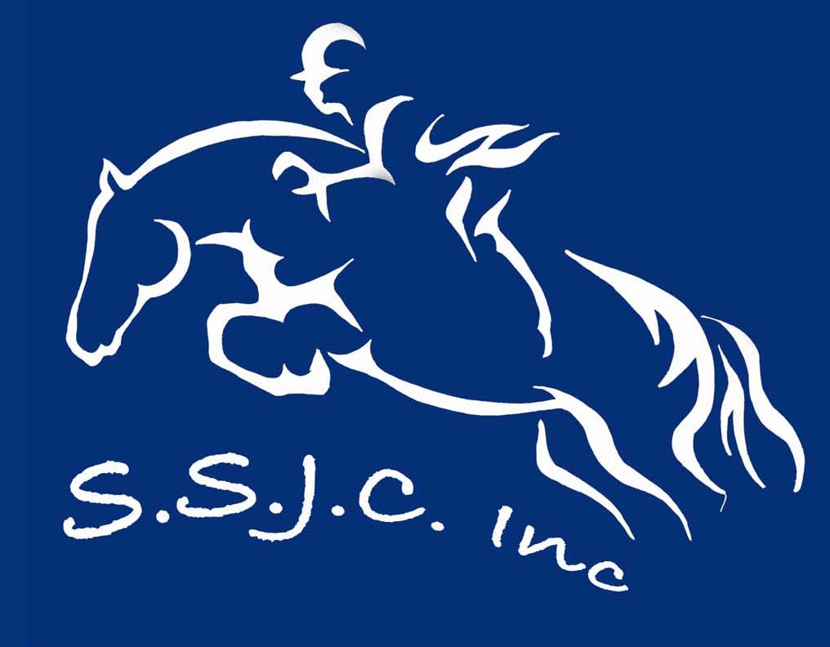

SYDNEY SHOWJUMPING CLUB MEMBERHIP APPLICATION/RENEWAL 2008
SSJC Membership and Disclaimer For the period 1st Jan to 31 December 2008
Sydney Showjumping Club Inc. Racecourse Road, Clarendon, NSW

Full Name (& of guardian if under 18 years)......………………………………………….........................................................
Full names of all family members if applying for a family membership………………………………………………………….
…………………………………………………………………………………………………………………………………………..
Address..................................................................................................................……………………………………….......
Post Code..........................Date of birth...………...........………...Home Phone: ………………………………………………
E-mail (For newsletter): …………………………………….……… Mobile Phone: ………………………………………..……
EFA Membership Number (Not Mandatory):………………………………….
Membership type (Circle): Annual Family $70, Annual Individual $60 Non-Riding $10.

In consideration for being permitted to participate in any way in horse sport activities, I, the
undersigned, understand, acknowledge and accept that:
- Horse sports are a dangerous recreational activity and horses can act in a sudden and unpredictable (changeable) way, especially if frightened or hurt.
- There is a significant risk that serious INJURY or DEATH may result from horse sport activities.
- I knowingly and freely assume all such risks, both known and unknown, and I voluntarily PARTICIPATE at my OWN RISK and assume sole responsibility for any injury, death or property damage I may suffer that arises from my participation in horse sport activities.
- I understand and acknowledge the dangers associated with the consumption of alcohol or any mind altering drugs before and during the activities and I take full responsibility for any injury, loss or damage associated with their consumption.
- I agree not to drink alcohol or take drugs prohibited by law before or during any horse sports activities.
- I agree to follow the directions of any event organiser or official and that any misconduct or refusal by me to follow any direction of any organiser or official can result in the CANCELLATION of my participation in the activities and my immediate removal from my horse NO MATTER where that may occur. I understand that any such non-compliance may result in injury, death and/or permanent disability as a result of my failure to comply.
- I agree to wear a helmet at all times whilst riding where this is required under the relevant EFA and FEI rules and regulations and agree that I am solely responsible for ensuring that whilst riding I wear a suitable helmet at all times where required under the relevant EFA and FEI rules and regulations and take sole responsibility for my actions.

I apply for membership of Sydney Showjumping Club and agree to be bound by the rules of its constitution.

I have had sufficient opportunity to read this assumption of risk agreement, fully understand its terms and sign it freely and voluntarily.

Dated: ___/___/___ Signature of Rider/Applicant: ………………………………………………………………………………

For Participants of Minority Age (Under Age 18)
This is to certify that I, as a parent/guardian with legal responsibility for this participant,
acknowledge, understand and accept ALL OF THE ABOVE and consent and agree to my minor
child's involvement or participation in horse sport activities.

Dated: ___/___/___ Name of parent/guardian…………………….……...…Signature of guardian……………..…..…………
Cheques made out to: Sydney Showjumping Club Inc
Mail to: Sydney Showjumping Club PO Box 30 Windsor NSW 2756

